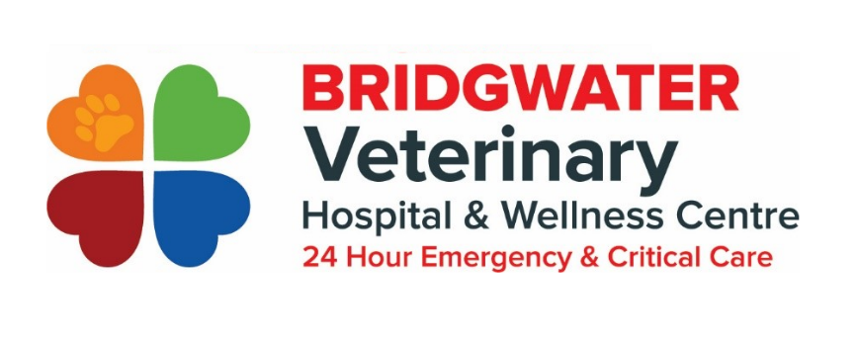Phone: (204) 452-0911
Fax: (204) 269-9031
info@bridgwatervethospital.ca
100-350 North Town Rd

Rehabilitation Referral Form
Referring Clinic Information
Date of Referral:
REGULAR CLINIC:
Client Information

Client Name(s):

Primary Phone Number:

Additional Phone Numbers:

Client Address:

Postal Code:

Client Email:

Patient Information

Patient Name:
Patient Breed:
Patient Age:
Patient Species:
Patient Sex:
Spayed or Neutered:
History
Presenting Concern:

Needed bladder expressed

Previous Medical Concerns:

Current Medications:

Please attach recent radiographs
All medical files will be emailed to patient’s regular clinic upon completion of appointment.
STF 󠆄
I have informed that client that there is a $60 cancellation fee for any cancellations with less than 24 hours’ notice.

